Project Design Phase(4)

StaffSync Solution Architecture
Team ID | Not assigned — individual project
Project Name | StaffSync
Maximum Marks | 4 Marks
Prepared by Abhigyan Dwivedi · Individual capstone
Solution architecture
One React application renders role-aware HR, Employee and Manager dashboards. It calls a Node.js/Express REST API. Controllers access MongoDB only through Mongoose models; the browser never receives database credentials.
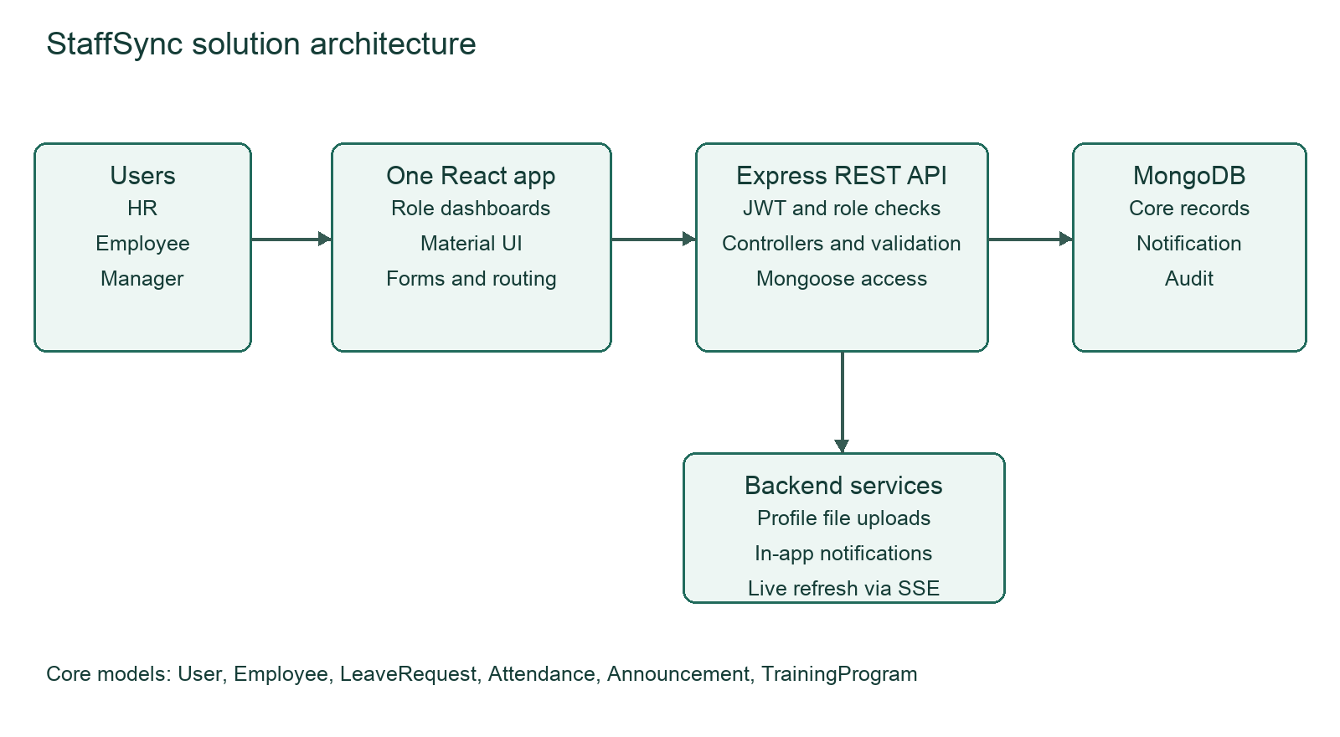
Layer | Responsibility
React frontend | Material UI, routing, Redux state, forms and dashboards
Express API | JWT verification, role and record scope, validation, controllers and response handling
MongoDB and Mongoose | User, Employee, LeaveRequest, Attendance, Announcement and TrainingProgram; supporting Notification and Audit
Backend services | Profile uploads, in-app notifications and server-sent refresh events

Request path: route → authentication and role/scope checks → input validation → controller → Mongoose → MongoDB → JSON response. Backend folders remain separated into config, models, middleware, controllers, routes and services.

